**Baby Massage**

[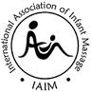](http://www.google.co.uk/imgres?q=baby+massage+IAIM&hl=en&gbv=2&biw=1280&bih=717&tbm=isch&tbnid=ZHInuKwva9WFMM:&imgrefurl=http://www.babistic.co.uk/about-iaim/&docid=iNC4BzXjBvYCwM&imgurl=http://www.babistic.co.uk/media/270/iaim-logo.gif&w=120&h=122&ei=wpLSTubVOs2DhQeaqejsCA&zoom=1)

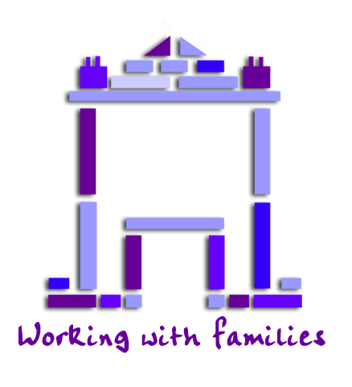

Do you have a baby under 7 months old?

Would you like to learn how to massage your baby?

Toyhouse has IAIM qualified Instructors and runs courses for parents at:

The Toyhouse Centre, 92 St. Paul’s Way. E3 4AL

**The next course will start with session 1 on: TBC**

**And the following sessions TBC**

**(Unfortunately, older children cannot attend the classes)**

* **4 x one hour classes run over 4 consecutive weeks**
* **A full body routine & a short routine to help with colic**
* **Handouts and time to share experiences**
* Groups will be small & places limited to ensure social distancing and you will be expected to attend for the full 4 sessions to enable you to cover the full body routine. If you would like to attend please complete the application form below and we will get back to you. If numbers exceed places we may put on a second course
* Or for more information please contact:

**Julie or Pip on: 020 7987 7399 or email:** [**info@toyhouse.org.uk**](mailto:info@toyhouse.org.uk)

**..................................................................................**

**Baby Massage application form**

Adult details (Please print clearly)

|  |  |  |  |
| --- | --- | --- | --- |
| Parent /  Carer Name/s | Ethnicity | D.O.B |  |
| Relationship to child(ren) | Language(s) Spoken | | Interpretation Needed |
| Address | | | Postcode |
| Telephone | Email (please print) | | |
| Where did you hear about the course? | Does your child have any additional needs? | | |

Child details

|  |  |  |  |  |
| --- | --- | --- | --- | --- |
| First Name | Last Name | D.O.B | Gender  M/F | Ethnicity |
|  |  | / / |  |  |
|  |  | / / |  |  |

Date _____/____/______